Lab 3 – Campus Cafe Order System
Name: Muhammad Hamza Awan
Roll No: 04072313045
Seed: 45 (t = 4, u = 5)

Step 1 – Classes and Objects
In this step, I created a Dish class with a name and price. I then created two different dish objects and assigned their values using my roll-number-based values.

Output Screenshot
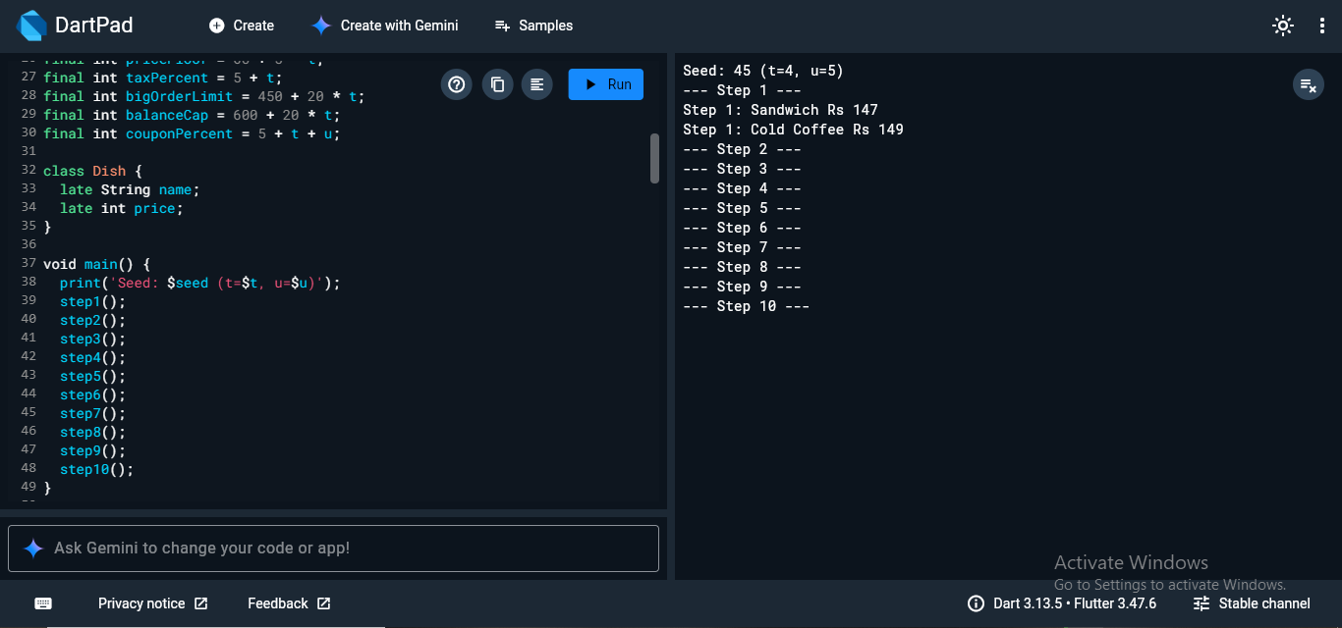

Step 2 – Constructor and this
In this step, I created a MenuItem class with a constructor. The constructor uses this to assign the name and price. I also added a minimum price rule.

Output Screenshot
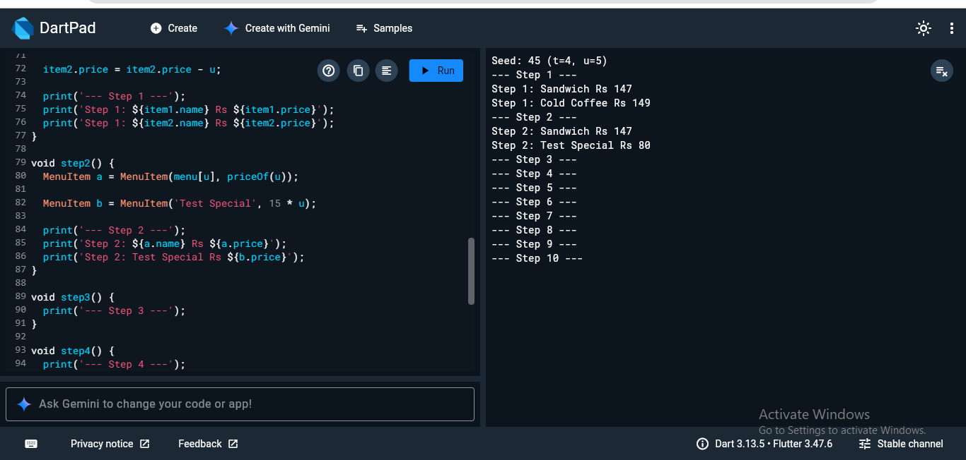

Step 3 – Named Constructors
In this step, I added two named constructors: free() and fromString(). The first creates a free item, while the second creates a menu item from a text string.

Output Screenshot
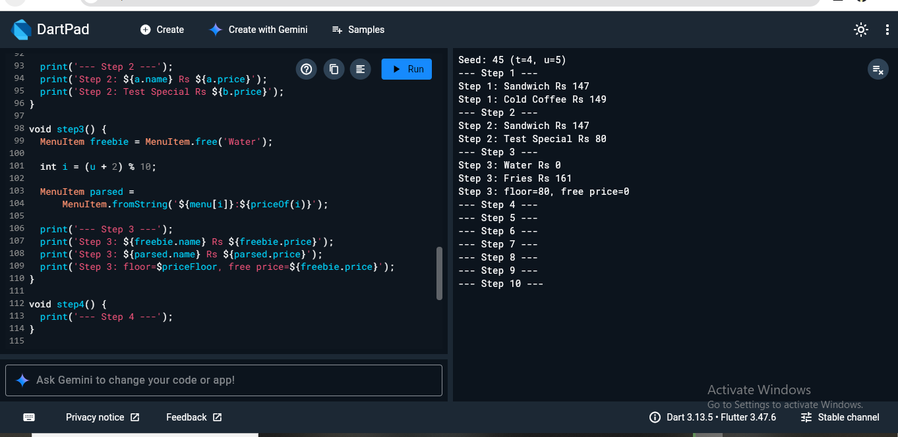

Step 4 – Factory Constructor
In this step, I created an OrderLog class using a factory constructor. It makes sure that both objects refer to the same shared object and store their entries in the same list.

Output Screenshot
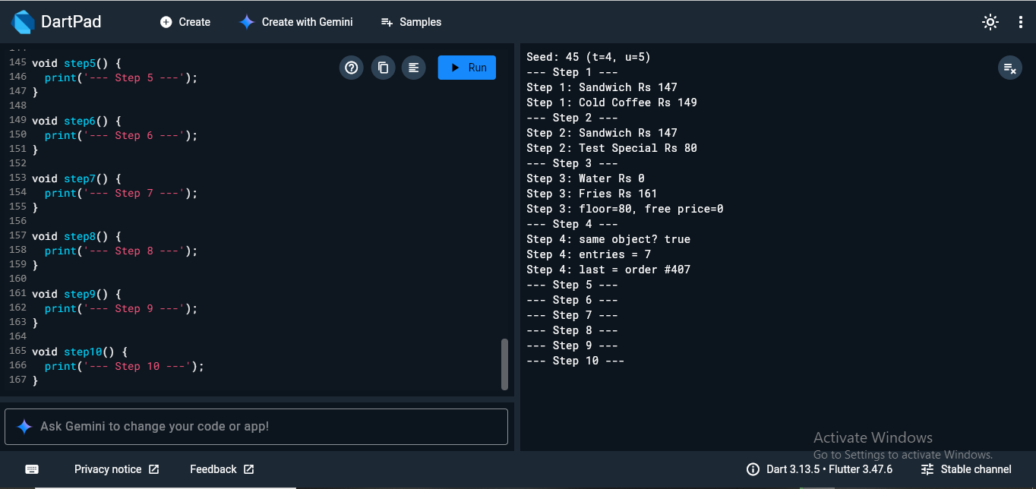

Step 5 – Initializer List and Assert
In this step, I created an Order class using an initializer list. I also used assert to make sure that the table number stays within the allowed range.

Output Screenshot
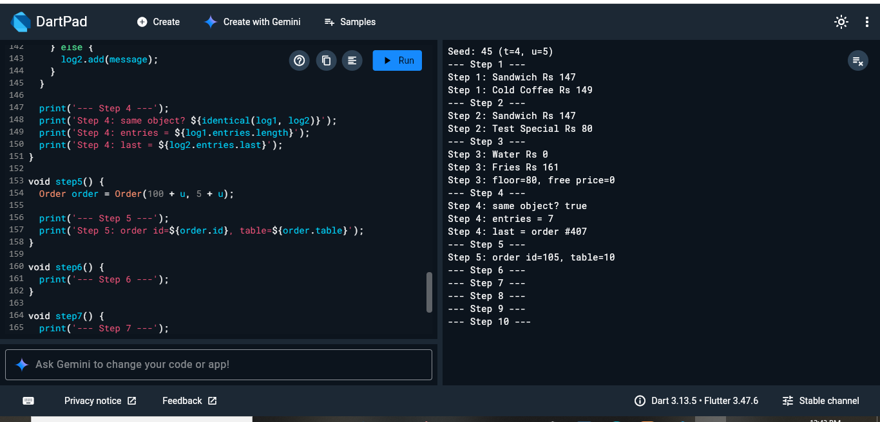

Step 6 – Getter
In this step, I added a getter called label. It combines the order ID and table number and allows me to access them in a simple format.

Output Screenshot
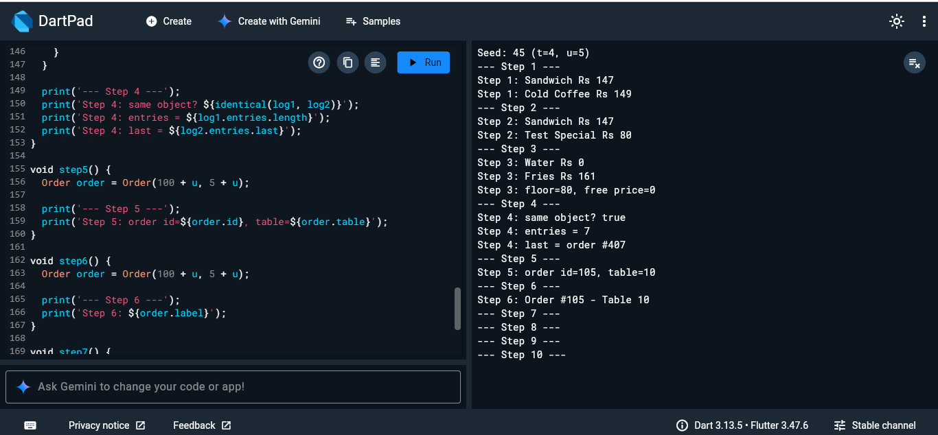

Step 7 – Setter
In this step, I added a setter to change the table number. The setter also checks that the new table number is within the allowed range.

Output Screenshot
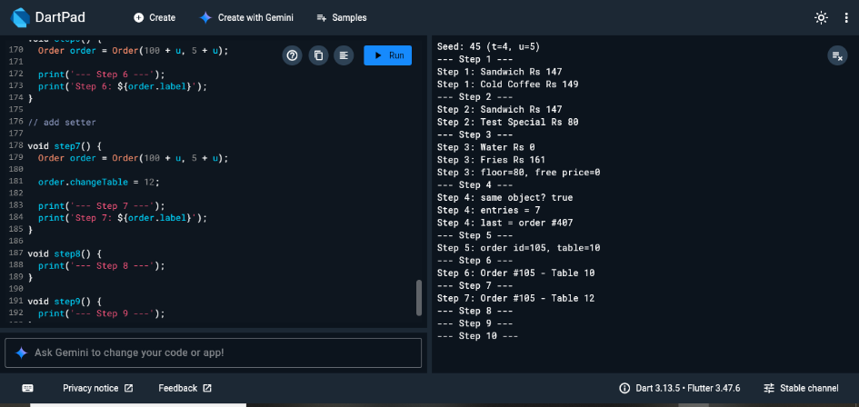

Step 8 – Menu and Collections
In this step, I created a list of menu items using a collection. I used a loop to add all the cafe menu items and display their names and prices.

Output Screenshot
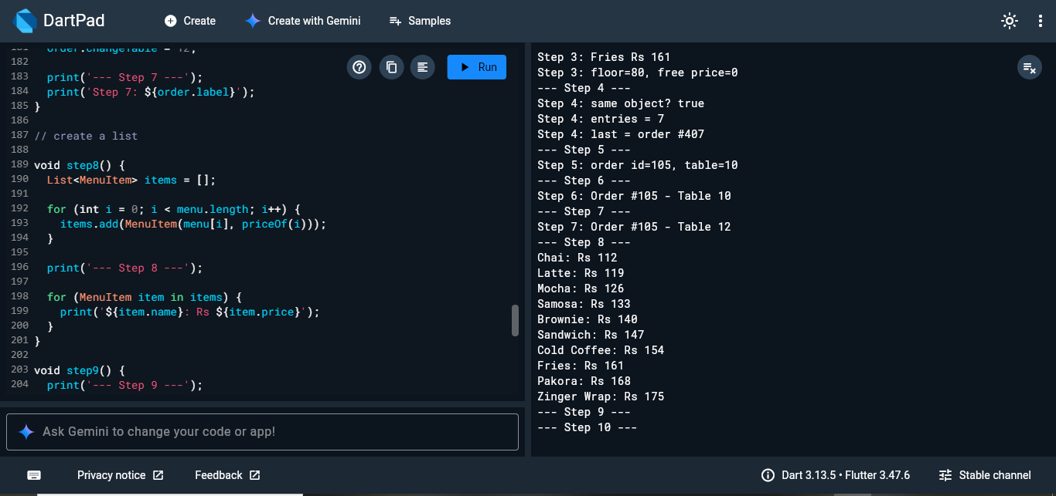

Step 9 – Receipt
In this step, I calculated the order subtotal, tax, and final total. I also displayed the selected items and their prices as a simple receipt.

Output Screenshot
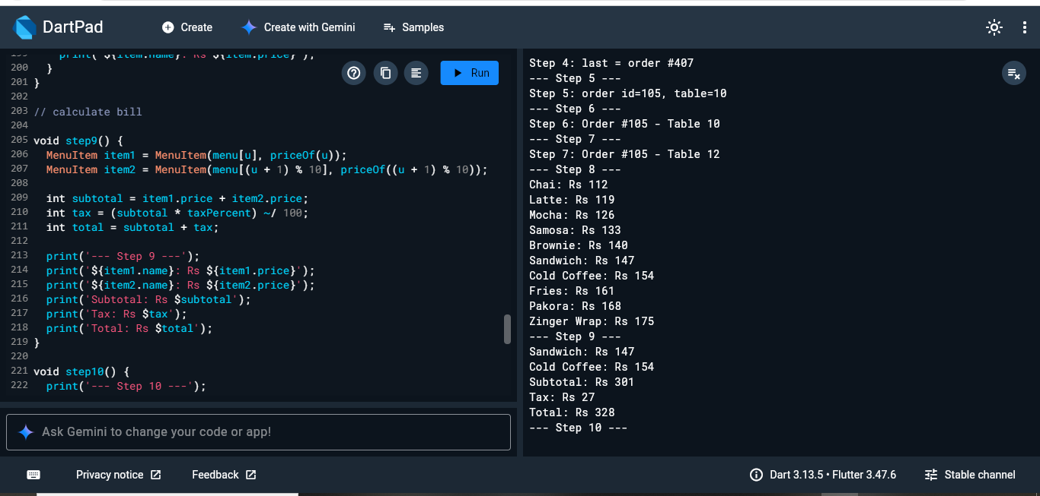

Step 10 – Coupon Capstone
In this final step, I applied the coupon discount to the order. After calculating the discount, I calculated the tax and final amount that the customer has to pay.

Output Screenshot
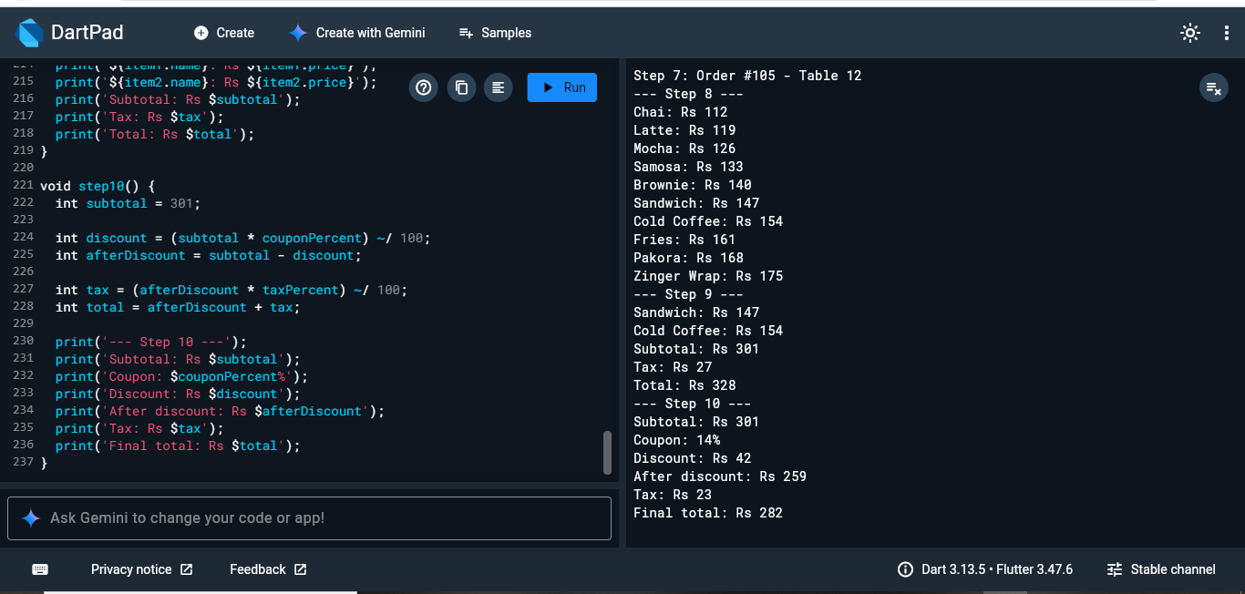

Conclusion
In this lab, I practiced important Dart concepts including classes, objects, constructors, named constructors, factory constructors, initializer lists, assertions, getters, setters, collections, and basic order calculations. The lab also helped me understand how these concepts can be combined to build a small cafe ordering system.

